Case

A 35-year-old woman born from nonconsanguineous parents presented with a very slow progressive difficulty in walking that started when she was 24 years old. Nine years prior, when she was 15 years old, she developed a mild right-arm writing tremor. During the following years, she developed a head tremor. Her gait worsened, and she became dependent on a walking stick 2 years ago. Cognition was normal. Her mother and aunt also had tremor, probably related to essential tremor. Examination disclosed mild pes cavus, brisk deep tendon reflexes, weakness and spasticity in the lower limbs with bilateral Babinski sign, and head dystonic tremor with a marked tilt of her head to the right. The tremor had a transient improvement if the patient touched her mental region, and this phenomenology was interpreted as a sensory trick. She also had a paraparetic gait (Video S1). General blood tests, albumin, alpha-fetoprotein, vitamin E, and phytanic acid were normal. Brain MRI showed a mild and bilateral hyperintense signal in the superior cerebellar peduncles (Fig. 1). Electromyography showed dystonic tremor with activation of sternocleidomastoids, bilateral splenium capitis, and right trapezius (Fig. 2). Somatosensory evoked potential showed prolonged latencies. Genetic testing for the most common spinocerebellar ataxias (1, 2, 3, 6, 7, 10), dentatorubralpallidoluysian atrophy, Friedreich ataxia and fragile X–associated tremor, and ataxia syndrome were negative. Whole-exome sequencing was performed and revealed compound heterozygous mutations NM_007055.3 (POLR3A): c.1909 + 22G > A and NM_007055.3 (POLR3A): c.1114G > A (p.Asp372Asn) of the POLR3A gene, which were classified as definitely pathogenic mutations. Segregation with genetic testing in the parents also showed the afore mentioned mutations. Variant c.1909 + 22G > A was identified as heterozygous in her mother, and variant p.Asp372Asn was found in the father. Therefore, the variants are found in different alleles in our patient. Multidisciplinary treatment with oral baclofen 30 mg daily and physiotherapy were started. Oral biperiden 4 mg daily has partially improved the head dystonic tremor.

Fig. 1

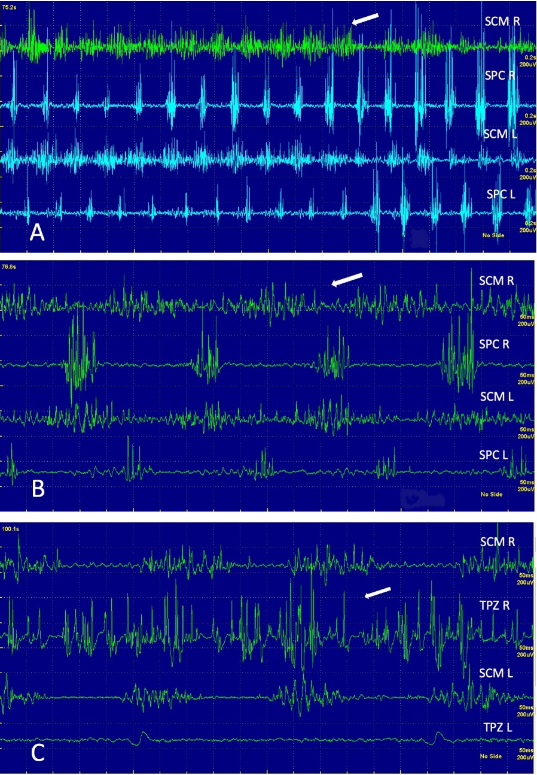
Fig.2

