Case Report

A 31-year-old man presented to our service with a one-week history of mild to moderate headache, binocular vertical diplopia, and behavioral changes described as disinhibition and excessive sleepiness. It evolved in the following days with slurred speech and difficulty walking. Twenty days before the onset of symptoms, he was diagnosed with SARSCoV-2 infection. He denied other systemic signs and symptoms, comorbidities, and environmental exposure.
He had mild lymphadenopathy and urticarial plaques on the face and proximal portion of the upper limbs, with associated excoriations on his physical examination. His neurological exam showed psychomotor slowing, inattention, dysarthria, bilateral vertical gaze and adduction paresis, right mild facial paresis, discrete dysmetria in the upper limbs, and broad-based gait with difficulty in tandem.
Brain MRI showed lesions with hyperintensities on T2 and FLAIR and iso signal on T1, mostly with bilateral and symmetrical distribution in the basal ganglia and cerebral peduncles in the midbrain with slight contrast enhancement.
Cerebrospinal fluid (CFS) showed moderate pleocytosis (50 cells/mm3, predominantly lymphomononuclear), without biochemical changes.
Empirical therapy for cryptococcosis and bacterial infection was started with amphotericin B, ceftriaxone, and ampicillin. Despite treatment, the patient had worsened, presenting a decreased level of consciousness and ophthalmoparesis, requiring orotracheal intubation.
Serum serologies for HIV, VDRL, Hepatitis B, arboviruses, toxoplasmosis (IgG and IgM), histoplasmosis, and cryptococcosis were negative. Rheumatological testing was negative, except for antinuclear antibody (ANA) with unspecific result (1:320 dense, fine speckled pattern).
Subsequent CSF analyses maintained the same pattern described. A wide, infectious screening performed with serology, genexpert, latex test, molecular testing (PCR), and metagenomic analysis was normal, including CFS PCR for toxoplasmosis.
A new brain MRI was performed that showed worsening of pre-existing lesions. He was than treated with immunoglobulin (2g/kg over five days) followed by methylprednisolone 1g/day IV for five days. He evolved with clinical worsening in the following weeks, presenting dysautonomia (hemodynamic instability, tachycardia, and hyperthermia), Cheyne-Stokes respiration, and spasticity affecting all four limbs.
A brain biopsy was planned. A new cerebrospinal fluid sample came positive for toxoplasmosis (PCR). Treatment with trimethoprim-sulfamethoxazole (TMP-SMX) 5 mg/kg/dose (TMP component) twice daily was started due to unavailability of first-line therapy.
After 2 months of admission, the serum serology for toxoplasmosis was repeated and was again negative. T-lymphocyte count (CD4+ 532 CD8+ 429 CD4/CD8: 1.240) and serum immunoglobulin (IgG and IgM) levels were normal.
Despite the absence of seroconversion, the patient evolved with subsequent remarkable clinical and radiological improvement, which reinforces the diagnosis of neurotoxoplasmosis.

Discussion

Toxoplasmosis is a disease described worldwide, caused by the protozoan Toxoplasma gondii. The prevalence can be quite variable according to geographic region. For example, in the United States, around 11% of the population has positive serology (IgG), while in Brazil, this rate reaches 78% of the population in higher risk areas. ^{1,2}
Infection in immunocompetent patients is usually asymptomatic (in up to 90% of cases) but may cause nonspecific constitutional symptoms such as mononucleosis-like illnesses, with spontaneous resolution after a few weeks. There have been some case reports with severe symptoms in immunocompetent patients, such as posterior uveitis, myocarditis, acute respiratory distress syndrome, pericarditis, hepatitis, and encephalitis, but these manifestations are extremely rare. ¹
In these patients, the diagnosis is usually made from the suggestive clinical manifestations and serum serologies. In atypical cases or in the suspicion of reactivation, molecular biology techniques such as polymerase chain reaction (PCR) can be used with high specificity (E > 96-100%). ³
However, in clinical practice, it is common for treatment to be instituted empirically due to the low sensitivity (S: 50-98%) of PCR from pre-test probability of neurotoxoplasmosis diagnosis. A compatible clinical manifestations and suggestive neuroimaging with multiple lesions with ring contrast enhancement predominantly affecting the basal ganglia region may be determinant in deciding the initiation of the therapeutic scheme. Stereotactic brain biopsies should be considered in atypical cases or with ineffective response after two weeks. ⁴
Treatment is divided into acute (6 weeks) and maintenance phases. The preferred initial regimen is sulfadiazine 1000mg (< 60kg) to 1500mg (> 60kg) 6/6h; pyrimethamine 200mg on day 1, followed by 50mg (< 60kg) to 75mg (> 60kg) 24/24h and folinic acid 15mg/day. Alternative regimens can be employed, such as sulfamethoxazole-trimethoprim (SMZ 25mg/kg or TMP 5mg/kg 12/12h) or clindamycin 600mg 6/6h in place of sulfadiazine in sulfa allergic patients. Maintenance treatment consists of the same medications at a reduced dose. In HIV-positive patients, treatment maintenance is recommended until the patient is asymptomatic on ART, with undetectable viral load and CD4 cells count > 200 cells/uL for six months. There are no well-defined recommendations regarding the duration of treatment in immunocompetent patients. ⁴
In the case described the diagnosis of neurotoxoplasmosis was determined after the second PCR collected in the CSF and evolution with remarkable clinical and radiological improvement after the introduction of sulfamethoxazole-trimethoprim (first-line regimen unavailable). Despite the non-reactive serology and the undetectable first CSF PCR for toxoplasmosis, a positive PCR result is considered to confirm the presence of active infection due to its high specificity (E > 96-100%). ³
A neuroimaging pattern suggestive of classic neurotoxoplasmosis involvement like that found in immunocompromised patients is observed in several reports. In the present case the lesions were in the usual topography (basal ganglia) but with atypical characteristics (no nodular pattern or ring enhancement), which made the diagnosis even more difficult. ^{1,5,6,7,8}
We conclude that one should be very cautious when excluding the diagnosis of neurotoxoplasmosis, even in immunocompetent individuals with negative complementary exams (serology, PCR). We also emphasize that the imaging pattern may be atypical and that there should be great suspicion for the diagnosis. In undefined cases, a brain biopsy should be early considered for etiological definition and appropriate clinical management.

References
- PUSTORINO, Giuseppe et al. Cerebral toxoplasmosis diagnosed by brain tissue PCR analysis in an immunocompetent patient. Neurology: Clinical Practice, v. 7, n. 5, p. 436-438, 2017.
- PAPPAS, Georgios; ROUSSOS, Nikos; FALAGAS, Matthew E. Toxoplasmosis snapshots: global status of Toxoplasma gondii seroprevalence and implications for pregnancy and congenital toxoplasmosis. International journal for parasitology, v. 39, n. 12, p. 1385-1394, 2009.
- ROBERT, Marie Gladys et al. Molecular diagnosis of toxoplasmosis: recent advances and a look to the future. Expert Review of Anti-infective Therapy, v. 19, n. 12, p. 1529-1542, 2021.
- MOFENSON, Lynne M. et al. Guidelines for the prevention and treatment of opportunistic infections among HIV-exposed and HIV-infected children: recommendations from CDC, the National Institutes of Health, the HIV Medicine Association of the Infectious Diseases Society of America, the Pediatric Infectious Diseases Society, and the American Academy of Pediatrics. MMWR. Recommendations and reports: Morbidity and mortality weekly report. Recommendations and reports/Centers for Disease Control, v. 58, n. RR-11, p. 1, 2009.
- AKTURK, Halis Kaan et al. Toxoplasma infection in an immunocompetent host: possible risk of living with multiple cats. Cureus, v. 9, n. 3, 2017.
- LIMA, Karlla Danielle Ferreira et al. An atypical case of neurotoxoplasmosis in immunocompetent patient. Radiology case reports, v. 16, n. 7, p. 1766-1769, 2021.
- DE OLIVEIRA, Gustavo Henrique Reis et al. Neurotoxoplasmose em paciente imunocompetente: relato de caso. Arquivos Brasileiros de Neurocirurgia: Brazilian Neurosurgery, v. 34, n. 03, p. 225-228, 2015.
- ESCALADA, Regin Filamel R. et al. Cerebral toxoplasmosis in an HIV-negative immunocompetent young man. Neurology Asia, v. 26, n. 2, p. 407-411, 2021.

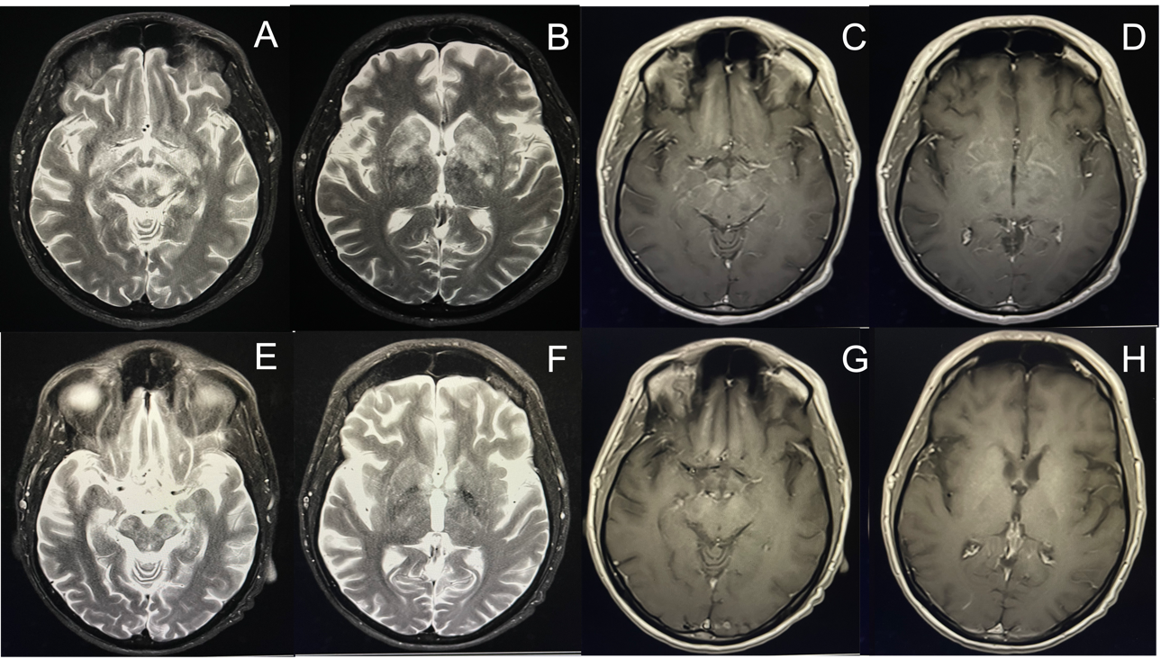
Figure 1. (A-D) Brain MRI demonstrating lesions with hyperintensities on T2 and iso signal on T1, mostly with bilateral and symmetrical distribution in the basal ganglia and cerebral peduncles in the midbrain with slight contrast enhancement. (E-H) Brain MRI performed approximately 1 month after the start of TMP-SMX, showing significant improvement of the lesions described above.

