**CASE REPORT: EXTRAMEDULLARY INTRADURAL HEMANGIOMA, A RARE AND CHALLENGING DIAGNOSIS**

**Case presentation:** 13 year old female patient with no previous health issues developed suddenly a diffuse abdominal pain. A few hours later, she presented an intermittent lower limbs paresthesia, which progressed to paraplegia and acute urinary retention. She denied previous infections or recent vaccination. At admission, neurological exam showed paraplegia, hypoesthesia in all sensory modalities in the lower limbs, sensory level at T8 on the left side and T6 on the right and bilateral extensor cutaneous-plantar reflex. Lumbar puncture was performed with a cellularity of 1/microL, glucose of 74 mg/dL (capillary glucose of 101), 12.2 mg/dL total protein. Magnetic resonance imaging of cervical, thoracic e lumbar spine showed a posterior laminar epidural collection between T6-T9 with associated myelopathy and also a thickening and contrast impregnation in the posterior dural region. Arteriography was performed with no abnormalities. She was referred for decompressive surgery in which a large local hematoma was found and decompressive drainage was performed. During procedure an absence of motor potential on monitoring was observed. Patient was referred to motor rehabilitation with physical therapy and also received corticotherapy with dexamethasone for edema management. This case report shows a rare cause of acute **myelopathy** in childhood. **Discussion:** Infantile hemangiomas are the main benign tumors found in childhood. However, neuraxial involvement is extremely rare with only about twenty percent of cases described in literature. The main causes of myelopathy in childhood are immune-mediated diseases, especially acute disseminated encephalomyelitis and viral infections by herpes viruses and enteroviruses. Among the vascular causes, arteriovenous malformation stands out. This case report presented itself as a challenging diagnosis which resolution was only possible after anatomopathological results. **Conclusion:** Myelopathies are neurological emergencies due to the risk of irreversible injuries, therefore it is important to pay attention to possible differential diagnoses and not delay treatment in case of spinal cord compression as well as inflammatory and infectious lesions.

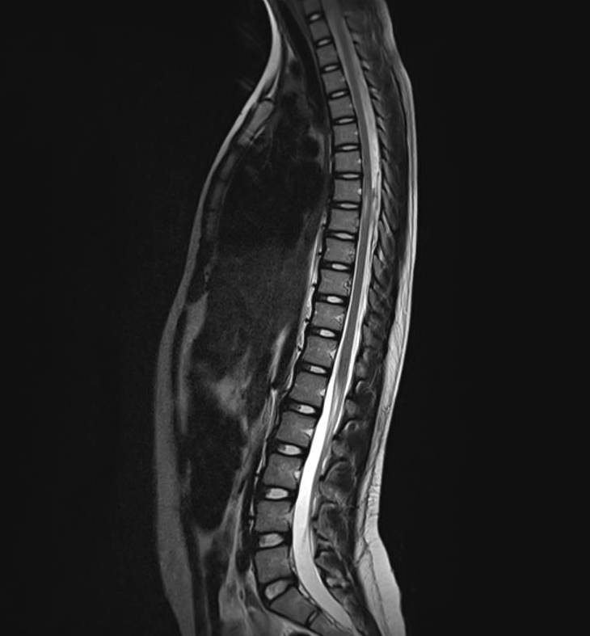

***Image 1:*** T2-weighted sagittal MRI show a posterior laminar epidural collection between T6-T9, with associated myelopathy.

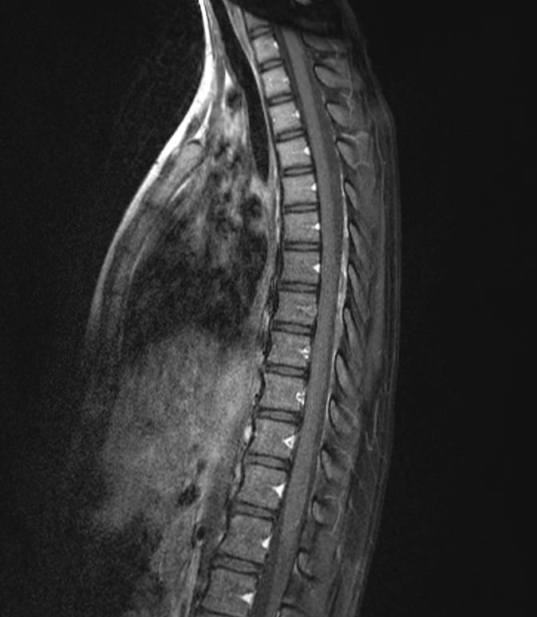

***Image 2:*** T1-weighted sagittal MRI show a showed thickening and contrast impregnation in the posterior dural region between T6 and T9.